**The First Church and Parish in Dedham**  [**www.dedhamuu.org**](http://www.dedhamuu.org)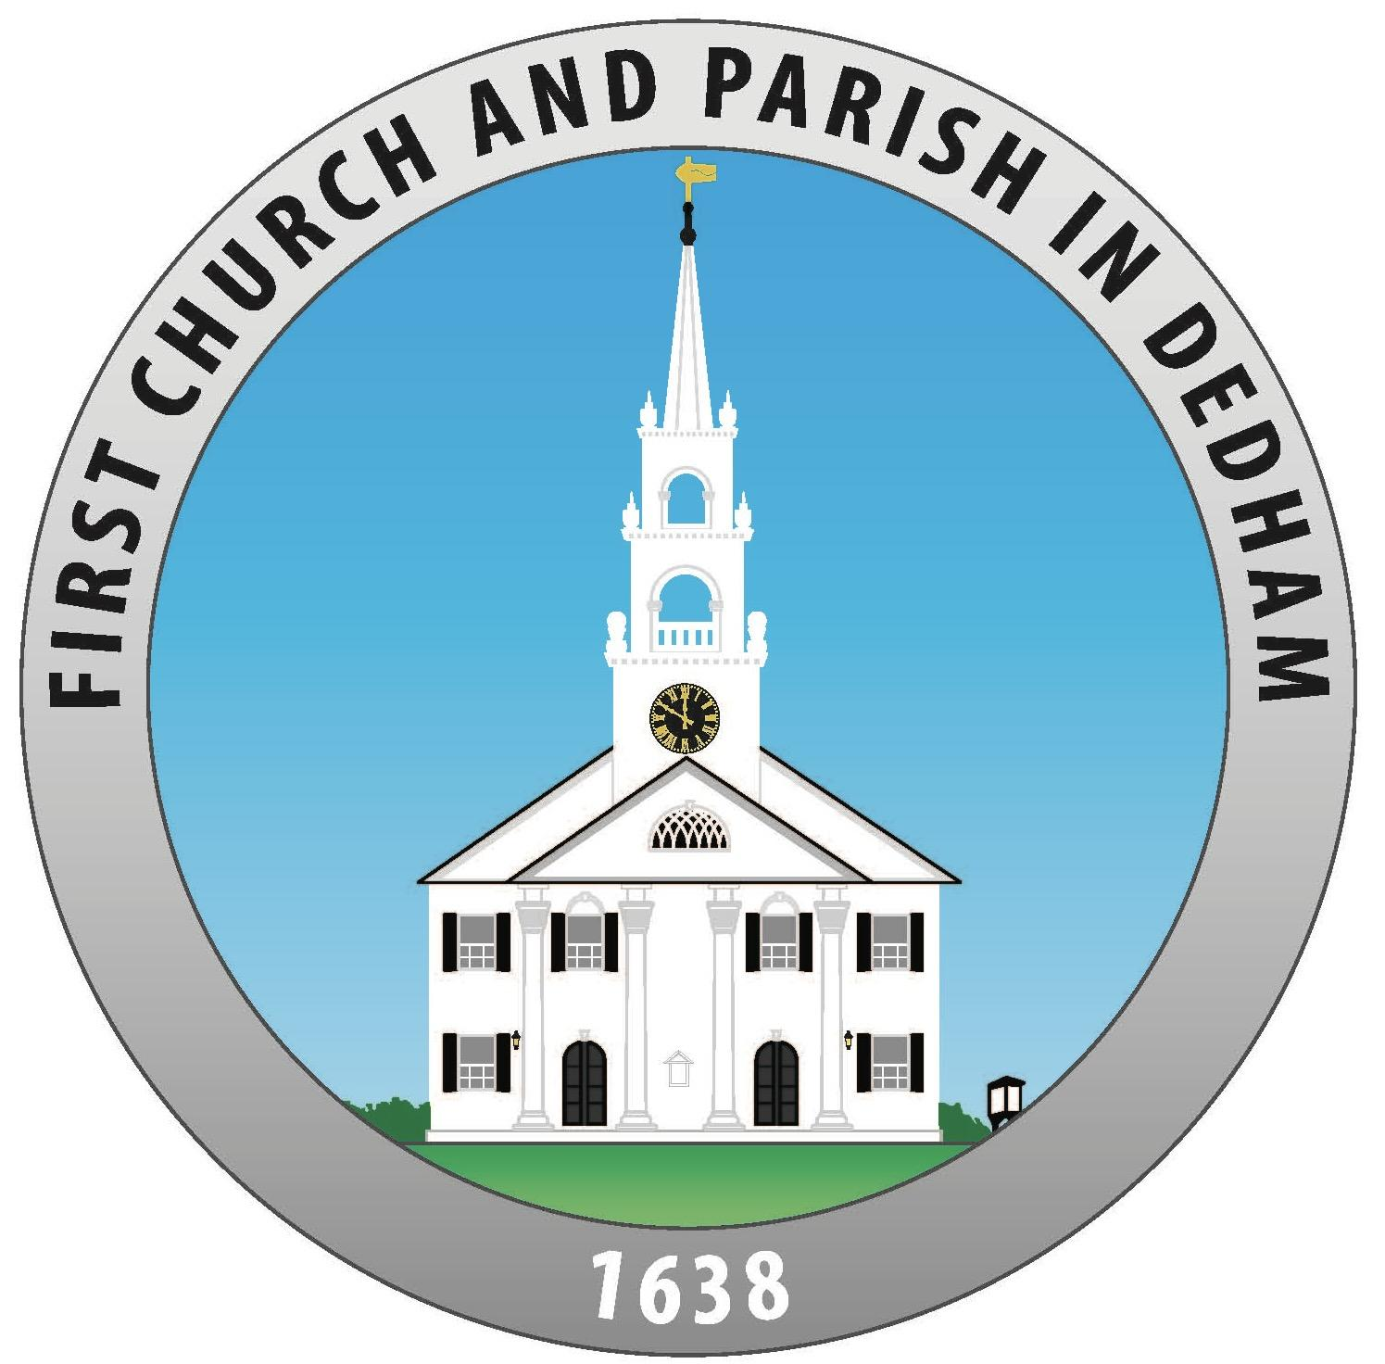

670 High Street, Dedham, MA 02026 781-326-7463

firstchurch@dedhamuu.org

Volume CXXXXV Number I September & October 2024

| **September 8, 2024**  **Homecoming Service**  **Starting with a Big Bang**  **and the beat of your own drum**  **Rev Rali M. Weaver and Matt Meyer**  **will preach**  We will consider the rhythm of change and how to set our heart’s rhythms amidst life's changes.  Drumming will ensue. We can't wait to see you!  Following worship, there will be a potluck picnic on the First Church green. Drinks and sandwiches will be provided, but sides, salads, and desserts would be appreciated.  **September 15, 2024**  **Wonder and Worship**  The Rev. Lillia Cuervo  On this Sunday, as we celebrate our RE program and the beginning of a new church school year, let us reflect on the importance of instilling a sense of transcendent mystery and wonder in our children and youth. Let us also reflect on how we can help them maintain a healthy relationship with that mystery and with those around them as they grow up in this overwhelming digital age.  **September 22, 2024**  **High and Low Context Communication**  **The Rev. Rali M. Weaver will preach**  Edward Hall, an American Anthropologist, first introduced the concept of “high-context communication” in the 1930s. Since then, the idea has been applied to various cultures and communication methods. This Sunday, we will explore how what we say and what is read between the lines may affect our everyday communication.  **September 29, 2024**  **Welcoming in Stranger**  **The Rev Hank Peirce will Preach**  Being a good neighbor is more than just a civic duty. It is in many religious communities a spiritual duty, as well. Today’s sermon playfully tells the story. | **October 6, 2024**  **Jovita Idár vs Woodrow Wilson**  **The Rev. Rali Weaver will preach**  Jovita Idár was an American Journalist and teacher who defended the plight of Mexican Americans during the Mexican Revolution. In honor of Hispanic History Month, we will explore the plight of Mexican Americans through history and Idár’s arguments for the inherent dignity of all.  **October 13, 2024**  **Hymn Sing**  Music is a central part of our UU worship services.  This Sunday, you will get to choose your favorite hymns, and we will reflect upon the importance of music in Worship.  **October 20, 2024**  **The Blessing of Our Pets**  **The Rev. Rali Weaver will preach**  This Sunday, we will consider all that animals have to teach us. Everyone is invited to bring their animals to worship after church to celebrate their lives with us in a Blessing of Pets on the green.  **October 27, 2024**  **The Everlasting UU Faith**  **The Rev Tom Schade will preach**  What is the bedrock of our faith -- that which endures through victory or defeat, despite the enthusiasm of the day? Let's take some time out from the ever-flowing stream of events to consider the everlasting present.  **November 3, 2024**  **Preserving Democracy in our Hearts**  **The Rev. Rali M. Weaver will preach.**  This Sunday before election day, we will explore our fifth UU Principle, “The right of conscience and the use of the democratic process within our congregations and in society at large.” |
| --- | --- |

**Our Minister: The Rev. Rali M. Weaver**

Thanks to all of those who were able to attend the July 10th conversation about my entry into a limited part-time contract ministry relationship with Falmouth UU. I left that meeting feeling there was so much left unsaid. I wanted so much to communicate the ways that a shared ministry with Falmouth might enhance both congregations. So often in life, our communication is more than words, and intention and impact are at odds. In September, in worship, I will reflect upon the importance of gathering in the community and the difficulties and pitfalls of communication. As I have said many times, I rarely preach a sermon that I don’t need myself!

I have been in a relationship with Dedham since 2007. I love Dedham and I love all of you. I have gotten married and raised children in this Parish. This is the most extended role I have held in my life, and I feel called to be part of all aspects of the health and well-being of our congregation and larger parish. Called ministry is a deep abiding connection that allows me to be here, witness all parts of your lives, and walk with you toward our mutual goals.

When Falmouth first asked me to help them I saw this as a win-win for our congregation. So many of you asked for more voices in the pulpit, as you experienced while I was on sabbatical. This is something our budget with a full time “Called Minister” is difficult to afford. By relinquishing part of my salary this would be an affordable option. Falmouth has also been forging new connections with the Mashpee Wampanoag Tribe through a program they call LINK (Linking Indigenous and Non-Indigenous Knowledge Inc). Given that we say a land acknowledgement each week I thought that it might be good to deepen our knowledge and understanding as well. From time to time I will share these events so that those of you who are interested can join in.

In contrast to a called ministry a contract minister is a reasonably new position proposed by the UUA. It is set forth to serve a short period with a covenant but not a call. Contract ministers tend to be more experienced, like me; they are not meant to disrupt a congregation (as interim ministers were trained to do in the past) but rather to bring some healing to and help guide a congregation toward its next steps. Unlike Interim Ministers, Contract ministers serve only a part time basis and can be called at the end of the one-year or multi-year contract ministry, yet this outcome is never assumed.

I hope that this year can be a time of discernment for our congregation. How much do you want our called minister in the pulpit? How might our congregation use our skills and experience to help strengthen another congregation? What might we learn from being in relationship with another congregation? These are all questions I hope we can live into in the coming year. I welcome all your questions and ideas and input and it is easy to make an appointment with me at <https://revraliweaver-dedham.youcanbook.me/> or as per usual 617-459-5979. There will also be opportunities for talk circles and worship evaluations and an evaluation of this process with Falmouth by the end of October. I am looking forward to engaging with you in an open and active conversation about what our church is doing well and what we can do better.

With love for our shared ministry to the world,

Respectfully submitted

Rev. Rali Weaver

Rev. Rali M. Weaver

Tuesday-Thursday 9-5 and other days and times by appointment

<https://revraliweaver-dedham.youcanbook.me/>

[raliweaver@dedhamuu.org](mailto:raliweaver@dedhamuu.org) or 617-459-5979

**September and October Visiting Ministers’ Bios**

September 8, 2024 **Matt Meyer** (with Rali and Darry)has led music and worship for hundreds of services in congregations all over the U.S. and Canada. Matt has a degree in hand drumming from Berklee College of Music and has studied abroad in Cuba, Ghana, and Central America. In addition to music, Matt is also an active community organizer and educator.

https://www.rhythmrevelations.com/

September 15, 2024, **The Rev. Lillia Cuervo**  The Rev. Lilia Cuervo, a native of Colombia, was the first Latin American woman ordained in the Unitarian Universalist denomination. At First Parish in Cambridge, she made history by being the first woman to be installed as a Parish Minister. She is a co-founder of the Latino/a UU Networking Association (LUUNA) and the initiator of and translator of several pieces for Las Voces del Camino, the Spanish language Unitarian Universalist hymnal. Her degrees include a Master of Divinity from Starr King School for the Ministry, a Master of Demography from Georgetown University, and a B.A. in Math & Physics from Women Teachers College, Bogota, Colombia.

September 29, 2024: **The Rev. Hank Peirce** comes from old swamp Yankee stock, whose family has belonged to our faith for centuries. He served congregations from Maine to Massachusetts and is the storyteller at First Church Boston. Hank lives in Medford with his family.

October 27, 2024: **The Rev. Tom Schade** is a retired UU Minister who served the First Unitarian Church of Worcester, MA, from 1999 to 2013. He has also served in leadership positions for the UU Christian Fellowship, the Unitarian Universalist Ministers Association, and the Unitarian Universalist Association of Congregations, including one term on their board from 2019 to 2022. He is currently working with the Board task force on By-Law Revisions. He lives in Plymouth, MA, with his wife, Sue, and two small dogs.

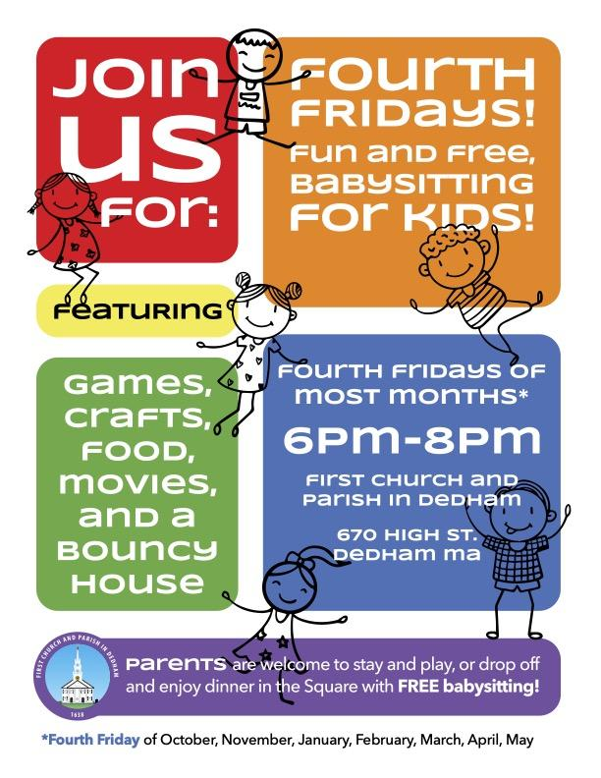

**Our Director of the Children’s UU Explorers Program: Lisa Pilat**

Hello, my friends and families,

The summer sure flew by!

I spent my summer working on a steeple restoration project for my church in Jamaica Plain. What an enormous undertaking that was, and it has given me a deep appreciation for historical architecture.

I have also been taking what is now called Spark classes towards my accreditation, and reading - lots and lots of reading! I look forward to returning to church in the first week of September.

We have a full schedule ahead for this Fall. I will be sending out registration forms next week so BOLO!

* Desi Langmead will be returning to the Nursery and will be there on 9/8.
* We are running OWL K-1 beginning in September. The parent/child orientation for that class is Monday, September 9th with the time TBD.
* UU Explorers will follow the Soul Matters curriculum. We have a new picnic table out back and plan to hold as many classes outside as we can!
* Neighboring Faiths will resume in September and will continue to explore other faith religions.
* Coming of Age also continues in September with many fun-off-site activities and will begin to form their credos.

The facilitators/teachers will be sending out Fall schedules soon.

I look forward to seeing you all on 9/8!

Peace and Love,

Lisa Pilat

Lisa’s office hours will be on Wednesday, 11 am-3 pm

You can reach her at lisapilat@dedhamuu.org

**Our Music Director: Darry Dolezal**

It’s time to sing! Our choir will sing in the Homecoming Service on September 8 - please feel free to join us! If not on the 8th then any Sunday. No great musical training is needed, just a desire to raise your voice with others. We meet every Sunday at 8:45am to rehearse, plus we have (optional) evening rehearsals on the 2nd and 4th Tuesdays of each month.

Darry

darrydolezal@dedhamuu.org

**Church Administrator: Grace Peña**

Hello! It feels like I was just writing my section of the Parish Record for July and August and telling you about the expected summer at First Church. Time does fly and now I look forward to seeing you all very soon for the new church year. It will be a great reunion!

I will return to working 15 hours a week: Mondays and Fridays, 10 am-3 pm, and Wednesdays, 1 pm-6 pm, while the Dedham Farmers Market is out on our green. That will last until the end of October. Then my Wednesday hours will change.

I can’t wait to hear all about the vacations, travels, things that made you laugh, made you smile and, most of all, I cannot wait until I see you all again.

I will be coming out with new coffee hour team information and the weekly church emails will start again soon. Keep a lookout for those things and so much more as we begin our new church year! Please let me know if you would like to be added to a coffee hour team and/or if you’re not receiving the weekly email.

With much love to all,

Grace

Grace’s office hours will be on Mondays and Fridays, 10 am-3 pm

and on Wednesdays, 1 pm-6 pm

You can reach her at firstchurch@dedhamuu.org

**Adult UU Exploration**

**Nature and Nurture Exploration** will begin again on the third Saturday of September 21 at Brook Farm, October 19 at Ridge Hill Reservation, November 16 at Arnold Arboretum, and December 21 at Shirley Eustis House. Rain or shine. All walks will start at ten and last approximately 2 hours, followed by lunch if desired. A transcendentalist reading will be shared with those interested for possible discussion. Contact [raliweaver@dedhamuu.org](mailto:raliweaver@dedhamuu.org) or 617-459-5979. All details will be in all church emails.

**Deepening our UU Connections**- Thursdays on Zoom 7-9 pm. New and Old to UUism, join us in exploring our UU faith and deepening our connections. We will be using the Soul Matters Small Group Ministry Curriculumn and we will take turns sharing our spiritual journeys, what brought us to our UU faith and exploring ways to deepen our faith. The theme for Soul Matters in September is Invitation and in October is Deep Listening. email [raliweaver@dedhamuu.org](mailto:raliweaver@dedhamuu.org) or call 617-459-5979 for the zoom link.

**Readers and Writers’ Group** will start up again on Thursdays from 5 to 6 p.m. https://us02web.zoom.us/j/83183979464. Join us to share your favorite readings or some of your own writing. This year, we will be working with writing prompts and trying to write more.

**Care and Concern**

In August we said goodbye to our dear friend Joan Wislocki. The family remembered her in a private ceremony. We, her friends at First Church, will remember her in many ways in the year ahead.

We continue to have parishioners who are not feeling well and/or cannot make it to worship or virtual services and would benefit from a call, a card, or a visit. Please reach out regularly to Kathy Elefterakis, Martha Leonard, Mary-Anne Osborne, Mary Daurio, and Priscilla King. If you have a care or concern to share or an address and phone number, please contact our church office by calling 781-326-7463 or emailing [firstchurch@dedhamuu.org](mailto:firstchurch@dedhamuu.org)

If you are interested in joining the Parish Community Network to reach out to those in need please contact [raliweaver@dedhamuu.org](mailto:raliweaver@dedhamuu.org).

**Civic Engagement**

**Dedham Food Pantry**

Dedham Food Pantry needs volunteers at this time. If you can help, please sign up by going to: <https://www.signupgenius.com/go/4090f4caca829a2f49-20201>

**Trunk or Treat** is scheduled for Tuesday, October 15th, 2024

If you would like to participate and are interested

**Housing Needed:** Gregory, Rose Myrtha, and Bedjali must leave the hotel they have been living in by the end of October. They are looking for a reasonably priced residence in the Dedham Needham area so that they can send the maximum amount of money home to help their families still in Haiti. If you know of any led-free residence, please contact raliweaver@dedhamuu.org or 617-459-5979.

**Historical Event**

**Bicentennial of Lafayette’s Farewell Tour**

Visits Dedham, MA

Sunday, September 22 at 1:00 PM

On September 22nd, First Church will commemorate Lafayette’s 1824 stay in Dedham by presenting a play adapted by Geoff Tegnell from a 1909 short story “The Passing of Lafayette,” by local writer Elinor Ramsay. This play will feature Reverend Rali Weaver and Tyler Carpenter and will be staged in the auditorium of First Church Parish Hall, 670 High Street, Dedham, MA 02026. This production will be prefaced by reading a diary entry recounting Lafayette’s whirlwind visit to Dedham as witnessed by Village Register editor Herman Mann (1795-1851). Attendance at this event will be free of charge.

**Musical Events at First Church**

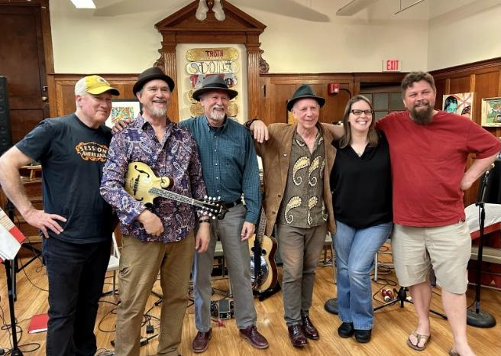

**First Church Friday Folk Coffeehouse** presents its first concert of the 2024-2025 season featuring Slow Boat Home in the Parish Hall atFirst Church and Parish Dedham 670 High Street, Dedham on Friday, September 20, 2024 at 7:30 pm in the Auditorium. There will be refreshments for purchase. Tickets are $15 and available at the door or online at Doors open at 7:00 pm.

Slow Boat Home is a fun-loving Americana band playing original tunes mixed with a lively collection of country, blues, jazz, and jug band music. Selecting many tunes from the first half of the 20th century, Slow Boat Home makes their own with stellar lead and ensemble vocals, harmonica, mandolin, bass, dobro, guitars, keyboard, and percussion. When it comes to influences, Slow Boat Home is an eclectic bunch. Jim Kweskin, Bonnie Raitt, Bessie Smith, Lee Dorsey, Mississippi John Hurt, Big Bill Broonzy, Toots & the Maytals, Jerry Douglas and many more supply musical inspiration.

First Church and Parish Dedham Unitarian Universalist was first gathered in 1638 and is located in Dedham Center at 670 High Street. Its lively music program includes its choir at Sunday services, the Parish Players theater troupe, and the **Concerts at First Church** concert series in addition to our Friday Folk Coffeehouse events.

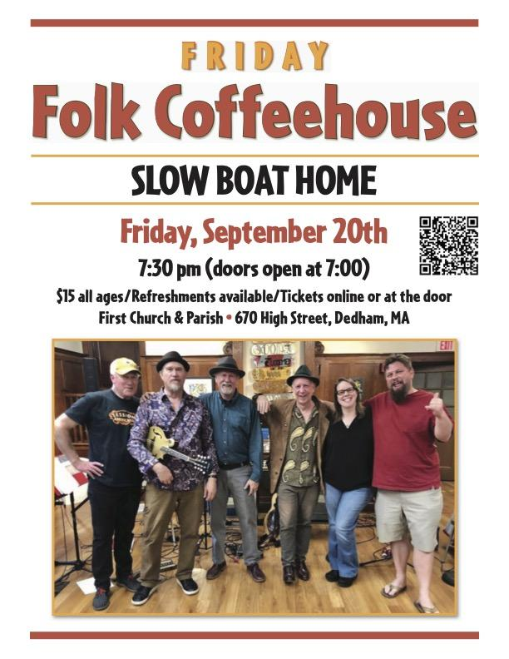

**HISTORICAL NOTES**

**Introduction:** Our resident historian, Geoff Tegnell, continues to explore some of the stories of our previous ministers so that we could share them with all of you. Geoff has been working to gather the stories of previous Ministers and Church Members.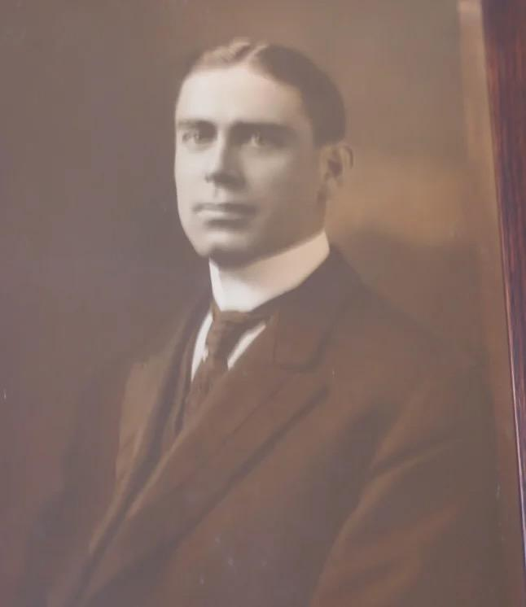

**Roger Sawyer Forbes (1903-1908)**

Roger Sawyer Forbes was born on October 24, 1878 in Westboro, Massachusetts, son of John Perkins Forbes and Maria Almy (Sawyer) Forbes. At his birth, Roger’s father was minister of the Unitarian Church of Westboro. Forbes spent his formative years in Westboro, Arlington, and Taunton, Massachusetts where his father served sequentially as Unitarian minister. Forbes attended Taunton’s Bristol Academy and Phillips Andover before entering Harvard’s class of 1900. After graduation he went on to earn a Bachelor of Sacred Theology from Harvard Divinity School in 1903. Over the summer of 1902, Forbes gained professional experience overseeing the services at the Liberal Christian Church at Sullivan’s Harbor, Maine and started to deliver guest sermons at Cambridge area churches early in 1903. Forbes preached his 3 rd trial sermon in Dedham on May 30, 1903 with such success that he was called by First Church leaders to become their minister in October of the same year. However, Forbes initially turned down an invitation to become First Church pastor because, as he stated in a letter to the Parish Committee representatives, “some of the members of your parish do not think it advisable to settle my ministry at present.” Furthermore, Forbes was under the impression that “others do not look with favor upon entrusting the pastorate to one so young as I.” The Parish Committee promptly called a special meeting on October 26, 1903 to enable congregants to vote for or against Forbes's call. When he heard that the final balloting indicated that 65 church members favored calling him. At the same time, only 2 opposed his becoming First Church minister, Forbes relented and was ordained and installed on December 2, 1903. Forbes’s tenure as minister of First Church was relatively short (4 ½ years), but nevertheless, impactful. To begin with, he energetically supported the fundraising, book collections, and clothing donation campaigns enacted by the Women’s Alliance and the youth clubs, like the Lend-A-Hand and What She Could Circles. For instance, when the Alliance was conducting a clothing drive for the African-American Kowaliga School in Alabama and the What She Could Circle held fairs to garner funds for the Penn Normal and Industrial School on St. Helen’s Island off the coast of South Carolina, Forbes served as the contact person. He also coordinated Lend-a-Hand Circle’s response to an appeal for clothing for the Children’s Island Sanitarium in Marblehead, a summer home for poor children with tuberculosis. In addition, as if he weren’t already busy enough, in February 1906 Forbes founded a new philanthropic church group, the Children’s Charity Club, ‘that was dedicated to supporting the work of Morgan Memorial, a pioneering Boston settlement house, by raising money staging theatrical events, sewing baby bibs, flannel skirts, and sacks, and arranging picnics for poor immigrant girls. Next, Forbes edited the Parish Record, the weekly bulletin about First Church services, events, and club and society activities. Lastly, Forbes played an active and innovative part in First Church programming. He chaired a committee that adopted a new hymnal, Hymns for Church and Home Unitarian Service Book. Forbes also redesigned the Sunday School course of study so that it “represents a progress from the simple, vivid rehearsal of early Bible stories to a consideration of the great problems of personal religion as they present themselves to the minds of the man and the woman today.” The youngest children were to study the “picturesque narratives” of the Old Testament after which older children were to spend a year learning about the life and teachings of Jesus. In the succession of grades, young scholars were then to study Old Testament history, the ethical teachings of Jesus, Paul’s letters, and a general summary of religious history from Paul’s time to the present. The course of study concludes with a comparative study of the principle Christian denomination with a focus on the “distinctive viewpoints of liberal religion.” Given the comprehensiveness and conceptual depth of this multi-year course scope and sequence, Forbes made provision for the predominantly female Dedham Sunday School teachers to train at Boston’s Tuckerman School which was dedicated to educating women who have “unquestionably entered upon a career in educational work destined to become a right arm to the churches, in making them more efficient through supplying them with parish assistants, directors of religious education, field secretaries, church school organizers and instructors in community service.” On November 3, 1907 Forbes married Mary Angeline Low with whom he ultimately had four children. Their wedding present from the Dedham congregations was the munificent sum of $700 in gold coins. Nonetheless, Forbes proffered his resignation as minister of First Church on March 15, 1908. As it turned out, in February 1908 Forbes had accepted the call to the ministry of the First Parish Church of Dorchester where he served as pastor until 1917, at which point he moved to Germantown, Pennsylvania to minister to its Unitarian Society. Forbes also a noted public speaker for the Unitarian Laymen’s League, lecturing widely on the principles of liberal religion and how they apply to modern problems He and Angeline retired to Petersham, Massachusetts, where Forbes died in 1938.

Bibliography

https://www.nytimes.com/1903/11/13/archives/call-to-brooklyn-divine-the-rev-roger-sawyer-forbes-

to-go-to-dedham.html

https://timesmachine.nytimes.com/timesmachine/1903/11/13/102029641.html?pageNumber=1

https://books.google.com/books?id=pRUUAAAAIAAJ&amp;pg=PA166&amp;lpg=PA166&amp;dq=Roger+Sawyer+Forbe

s&amp;source=bl&amp;ots=IFOlL6JSch&amp;sig=ACfU3U2TGDPuiv8wiSckk777A7zFdCDBlg&amp;hl=en&amp;sa=X&amp;ved=2ahUKE

wijstbBv_b4AhWGg4kEHQt9BEAQ6AF6BAgWEAM#v=onepage&amp;q=Roger%20Sawyer%20Forbes&amp;f=false

Roger Sawyer Forbes (born October 24, 1878), American clergyman | World Biographical Encyclopedia

(prabook.com)

https://iiif.lib.harvard.edu/manifests/view/drs:431831705$155i

https://www.harvardsquarelibrary.org/unitarian-universalist-history/john-perkins-forbes/

https://books.google.com/books?id=Rdk4AQAAMAAJ&amp;pg=PA218&amp;lpg=PA218&amp;dq=Roger+Sawyer+Forb

es&amp;source=bl&amp;ots=gCNvG7OTSJ&amp;sig=ACfU3U3ghEobc1BRWjcKQduO7Y87AmseHQ&amp;hl=en&amp;sa=X&amp;ved=2ahUKEwi74u_ZjL_5AhUKq4kEHXL5CJQQ6AF6BAgZEAM#v=onepage&amp;q=Roger%20Sawyer%20Forbes&amp;f=false Secretary&#39;s ... Report - Google Books

The Cambridge Tribune 9 August 1924 — Cambridge Public Library&#39;s Historic Cambridge Newspaper

Collection (dlconsulting.com)

Parish Record (1903-1908,) Dedham Historical Museum and Archive

First Church Records 1903-1964, Dedham Historical Museum and Archive

**PARISH COMMITTEE MINUTES**

First Church Parish Committee Meeting Minutes

Tuesday, June 4, 2024, 7:00 via Meeting on Google Meet

Minutes taken by: Ann Miranda, Clerk and Geoff Tegnell

In attendance via Zoom: Howard Ostroff, Geoff Tegnell, Carol Dixon, Mary Lynn Davis, Rali Weaver, Aoife Barrington-Haber, Matt Grady, Ann Miranda and Becca Vautour.

Howard Ostroff called the meeting to order at 7:05

Gratitudes

Meeting Minutes from May 7, 2024 approved with edits. Motion made by Geoff and second by Carol.

Treasurer Report

Fundraiser revenue (Friday Night events) was way over budget. Income is 93% and expenses are 97% on the year. Motion to accept the report was made by Mary Lynn, second by Carol

At the May meeting, $20,000 of the Parish Committee Restricted funds were approved to be moved into a money market account. The money market account rates were low so Howard moved the funds into a CD instead. Matt made a motion to move to accept moving the $20,000 in funds from the CD to money market fund in September when the 3 month DC is due. Matt will look into rates and make a suggestion. Approved by all.

Minister's Report was presented by Rali.

Rali is looking into a contract by a UU church in Falmouth that needs a minister. Rali would split time and be in Falmouth 2 times per month. Rali to contribute a portion of her salary to cover the substitute minister when she is not in Dedham. Rali thinks this move would be good for the church. Falmouth will make a decision by the end of June. If she is accepted, the position will start in July. The personnel committee is in touch with the UUA about Rali’s contract. Rali will be here until the end of June and will be on call in the summertime.

RE report was presented by Rali

In 2-3 years, Lisa will complete her RE credential program.

FY 2025 Budget presentation was made by Howard.

Expenses and projected income are increasing. The projected income is slightly higher in the next fiscal year. RE and music programs had increases that Women’s Alliance will support. The budget is included in the annual report(requires approval)

It was suggested to revisit the rates Baystate pays for utilities. Utilities have gone up 5.5%. It has been two years since the last increase. However, there were issues with the building that Baystate has had to deal with.

There were two items in the budget that needed to be adjusted. Changes will be made to the line for employment taxes and there should be $500 in the RE budget for DRE Professional Expenses. The revised budget will be sent to Parish Committee members and voted on either in person or via email.

Annual Meeting Agenda Review

Johnny Pape agreed to be moderator. Rali reviewed the process.

Personnel Committee report given by Howard Ostroff

Letters of agreement are being worked on and will be completed by the end of June. A meeting is planned with the UUA compensation team to discuss calculation of salaries and complexities relating to Rali’s letter of agreement.

Leadership Transfer

A motion was made by Matt Grady and seconded by Aoife Barrington-Haber to approve transfer of leadership of the Parish Committee to Co-chairs Rebecca Vautour and Mary Lynn Davis who will have signatory authority on all bank accounts.

In-person get together to be scheduled in June for current and new Parish Committee members. Next meeting date to be determined.

Dedham celebration of Lafayette Bicentennial-Geoff Tegnell

Other new business-Ann Miranda recused as Clerk. Meeting Minutes on the topic of “Other new business” were taken by Geoff Tegnell

Ann Miranda presented her concern about Farmers Market dealing with the parking issues. Ann wants the Building Use Committee to think seriously about future leases to outside parties and how they impact both the Market and the Church. She suggests that a policy be designed to avoid conflicts and potential misunderstandings. She is very worried about disruption of the Farmers Market and wants us to be more circumspect about circumstances that could negatively affect vendors and consumers. Rali and others agree that such a reflection on our leasing policy would be appropriate and productive.

Motion to adjourn made by Mary Lynn and accepted by all. Meeting ended at 9:01pm

June 8, 2024 Addendum to Meeting Minutes made by Ann Miranda, Clerk

On June 7, 2024, a revised budget was sent to all Parish Committee members. The revised budget was accepted by a majority of Parish Committee members on June 7, 2024.

Parish Committee Executive Meeting Minutes

August 13, 2024

Prepared by: Ann Miranda, Clerk

In attendance via Google Meets : Geoff Tegnell, Carol Dixon, Mary Lynn Davis, Aoife Barrington-Haber, Vicky Berg, Tom Donaghey, Ann Miranda, Lisa Brayton and Becca Vautour.

Meeting called to order at 7:36 by Mary Lynn Davis

Gratitudes

Treasurer Report

8% way through the year; income is in ahead of budget. Expenses are tracking where they should be.

Motion was made to approve the treasurer’s report and it was approved.

Meeting Regarding July Listening Session About Falmouth Opportunity

Rali is taking the opportunity no matter what. We need to start a search committee. Lisa Pilat can take on more responsibility. Rali will be a part time minister in Dedham and compensation needs to be decided upon. Rali gave a schedule of when she will be in Dedham or Falmouth. Rali is working on finding ministers to fill in but there are many weeks that are not covered.

A question was raised. Do we have a proposal from Rali in writing? We need Rali to submit a proposal to the Parish Committee by August 20, 2024 for committee review.

The question was asked if we have consulted with UUA. Mary Lynn has researched compensation on the UUA website.

Mary Lynn is attending the worship planning meeting tomorrow. Becca and Carol will also be on the Worship Committee. Co-chairs had a preliminary meeting with the personnel committee.

Carol will reach out to Falmouth to open communications.

Discussions were had about Rali’s current compensation.

Next meeting: Tuesday, September 3, 2024 at 7pm. Meeting to move to Mondays or Wednesdays beginning October.

Motion to adjourn made by Mary Lynn and approved by all.